**Technical deployment by Lip Chuan Sui**

After finishing the website in localhost, the website is ready to go live. First, user compressed the folder for Yokyo website into a zip file. Using a zip archive, an entire website can be uploaded in a single file. This allows user to upload files more quickly. After that, user have to purchase a domain name for website. In this case, the domain name should be Yoyko2020. Then, user have to choose a hosting platform for hosting website. I recommend user to choose Hostinger as hosting server because Hostinger prepares CodeIgniter hosting which allow user to develop and deploy PHP based applications. I recommend the Business CodeIgniter Hosting plan which cost 3.99 dollars every month which included SSL certificate. SSL certificate could improve the reliability of website and prevent hacking. After procuring a domain name and hosting plan, user could upload the zip file in cPanel.

After uploading the zip file, user should extract files from it. Then, user import sql script file into phpMyAdmin to create database. Please make sure the database configuration is same as in the database configuration file inside CodeIgniter. After that, user should base url in the configuration setting to make it is correct. The website should be launched properly. Furthermore, user should register a domain email using domain name and configure the email setting inside email configuration file. The email currently used is a private Gmail account. Private Gmail account should be replaced with domain email such as [info@yokyo2020.com](mailto:info@yokyo2020.com) because private Gmail will be blocked by visitors by default.

Email Configuration

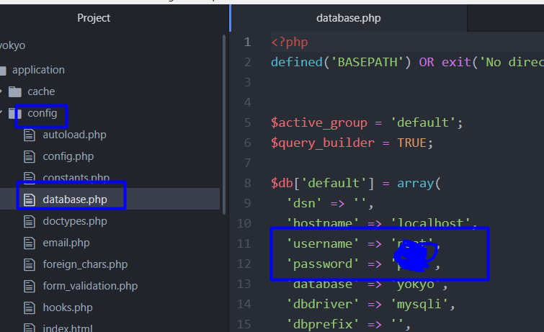

Database Configuration

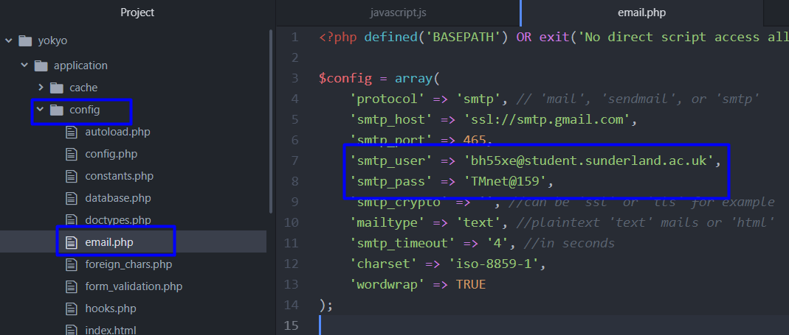

This website uses php framework CodeIgniter to build back end. Besides, html, css and JavaScript are used to develop the front end of website. Basic knowledge of these language are required to make further improvement and adjustment.

Furthermore, user could improve performance of website by implementing Google Search Console. Google Search Console could promote success in search results, mean visitors will likely to find it when google searching. Google Search Console provides feedback of the website such as click-through rates, search queries, crawl errors, links form another websites and errors. For example, user will receive email from Google Search Console about mobile usability issues detected for Yokyo2020. User could detect some issues such as text too small to read, clickable elements too close together and others.

Below is the email I received for my old client website.

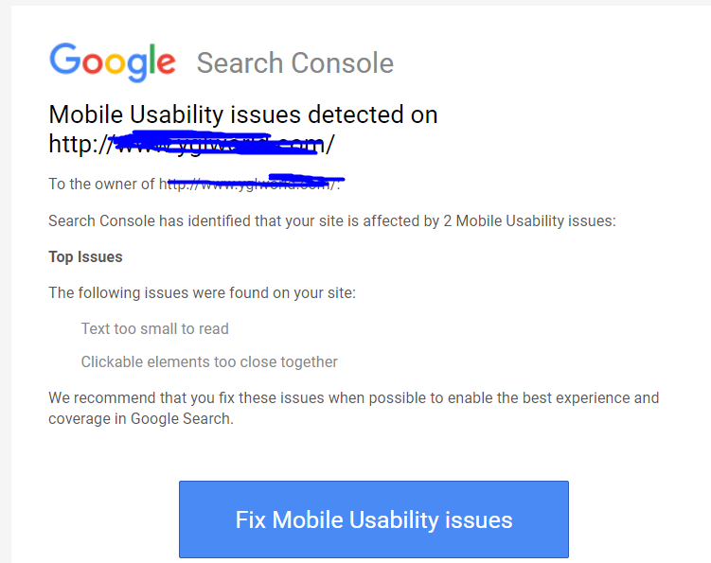

Last but not least, user could implement Google Analytics in the website. Google Analytics could provide traffic statistic such as like total site visits, bounce rate, average time on site, and demographic information. Having these data, user could further improve website reliability and availability.